|  |
| --- |
| PS2Win |
| Weekly Report |
| Keep Your Time |

|  |
| --- |
| Filipe Brandão  28-04-2013 |

**Team Members:**

Carla Machado

David João

Filipe Brandão

João Girão

João Martins

Mário Oliveira

Rui Ganhoto

**Week 10**, 22th of April to 29th of April

Content

1. Week Activities 1

1.1. Work Executed 1

1.2. Work Analyses 1

1.3. Achievements 1

2. Impediments 1

3. Plans For Next Week 1

4. Progress 2

4.1. Earned value and/or Gantt Image 2

4.2. Effort by task 2

4.3. Individual effort 3

5. Individual log 3

**Images**

Figure 1: Earned Value 2

Figure 2: Week effort by task type 2

Figure 3: Week effort by team member 3

**Tables**

Table 1: List of Contributors ii

Table 2: Version history ii

Table 3: Log of individual effort 3

|  |  |  |  |
| --- | --- | --- | --- |
| **Authors and Contributors** | | | |
| **Date** | **Name** | **Contacts** | **Contribution** |
| 28-04-2013 | Filipe Brandão | a21180276@alunos.isec.pt | Author |
|  |  |  |  |
|  |  |  |  |
|  |  |  |  |
|  |  |  |  |
|  |  |  |  |

Table 1: List of Contributors

|  |  |  |  |  |  |
| --- | --- | --- | --- | --- | --- |
| **Revision History** | | | | | |
| **Date** | **Description** | **Author** | **Version** | **Approvers** | **State** |
| 28-04-2013 | Creation of first draft | Filipe Brandão | 0.1 |  | Draft |
|  |  |  |  |  |  |
|  |  |  |  |  |  |
|  |  |  |  |  |  |
|  |  |  |  |  |  |
|  |  |  |  |  |  |
|  |  |  |  |  |  |
|  |  |  |  |  |  |

Table 2: Version history

# Week Activities

# Work Executed

* Verification & Validation Process approved
* SRS ready for Inspection
* Individual preparation for Inspection
* Started Database Entity-Relationship Diagram

# Work Analyses

Team members allocated to the SRS Definition asked for help to correct the language and get the document ready in time. Carla, being probably the team member with better English skills, volunteered herself and, with her help, we were able to provide do document in time.

Test plan production was halted due to the request from members defining the requirements. One of the members allocated to this task, preferred to test the new UI library than to stop working on the project.

# Achievements

* Baselined Verification & Validation Process
* SRS ready for Inspection

# Impediments

None identified.

# Plans For Next Week

* Inspection of the SRS
* Finish Test Plan
* Finish the Database Architecture
* Review (Walkthrough) the Database Architecture
* Re-estimation

# Progress

# Earned value and/or Gantt Image

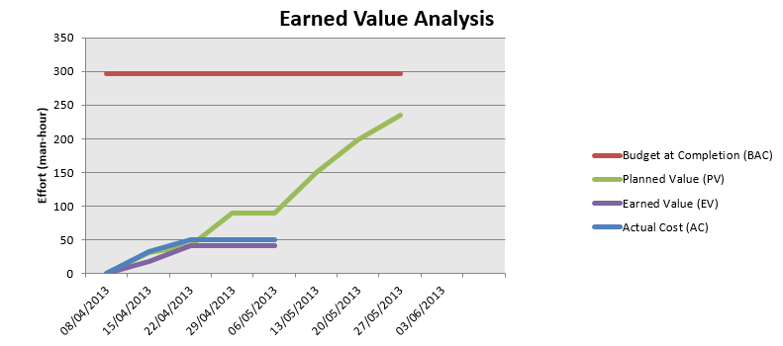

Figure 1: Earned Value

Planned Value = 41,3h

Earned Value = 41,3h

Actual Cost = 50h

# Effort by task

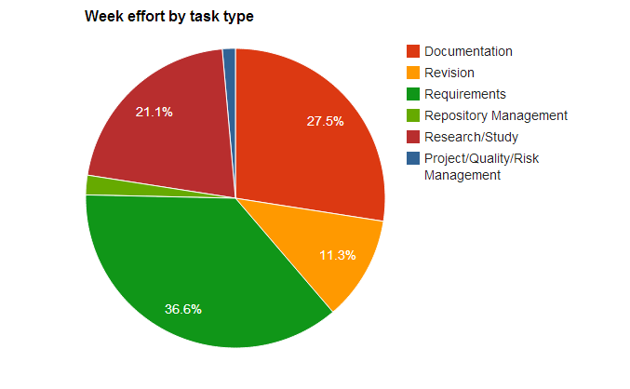

Figure 2: Week effort by task type

# Individual effort

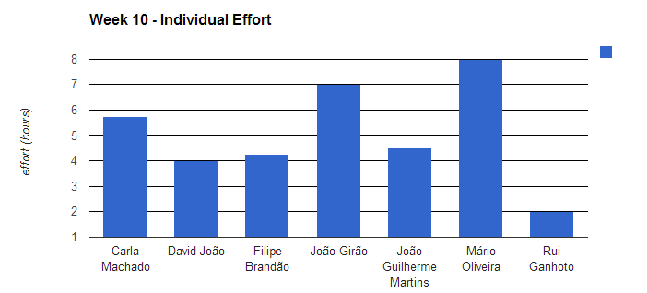

Figure 3: Week effort by team member

|  |  |
| --- | --- |
| **Name** | **Effort(hours)** |
| Carla Machado | 5.75 |
| David João | 4 |
| Filipe Brandão | 4.25 |
| João Girão | 7 |
| João Guilherme Martins | 4.5 |
| Mário Oliveira | 8 |
| Rui Ganhoto | 2 |

Table 3: Log of individual effort

# Individual log

**Carla Machado - Tasks done:**

* Quality activities - some verifications of the document measures and information in the logs 0.25h
* Approval of the weekly report of week 8 0.5h
* Review of the meeting minute of the week 8 0.5h
* Helping the requirements team in the definition of the requirements 2h
* Update of the SRS 1h
* Continuation of the SRS 1h
* Approval of Verification & Validation Process 0.5h

**David João - Tasks done:**

* Tiny Requirements Review 0.25h
* Study and take annotations of Javalicious Development Team's SRS for the inspection 2.25h
* Study of WPF fundaments and controls 1.5h

**Filipe Brandão - Tasks done:**

* Reviewed V&V Process and Processes List 0.5h
* Updated Logs and Dashboard to use a new task type (management) 0.5h
* Study of the SRS to prepare for the Inspection 1.75h
* Weekly report 0.5h
* ER Model 0.75h
* Added new task type (Management) 0.25h

**João Girão - Tasks done:**

* Requirements Definitions 5.5h
* Formatting and change SRS 1h
* Change verification and Validation Process (Ready for approval) 0.5h

**João Martins – Tasks done:**

* New tests 0.5h
* ER diagram 1.5h
* Study and take annotations of Javalicious Development Team's SRS for the inspection 2h
* Reading the SRS from my team 0.5h

**Mário Oliveira - Tasks done:**

* Revision weekly report - Week 8 0.25h
* Revision Process List 0.25h
* Upadate repository 0.25h
* Writing meeting minute 1.75h
* Requirements Definitions 1
* Requirements Definitions 4.5h

**Rui Ganhoto - Tasks done:**

* Weekly Report and Processes List Approval 0.5h
* Requirements Review 0.75h
* Meeting Agenda 0.75h